**Software Development Life Cycle and Waterfall Model**

* Waterfall Model  
  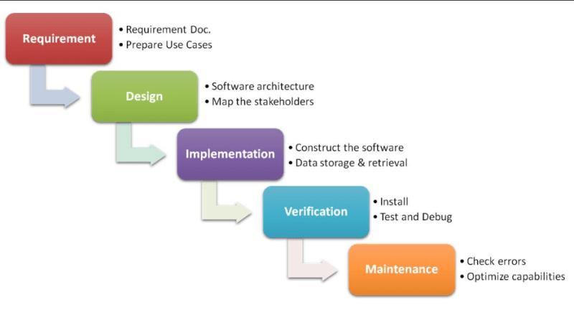
* Requirements:
  + Create a High-Level Requirements Document
  + Use Case Diagrams  
    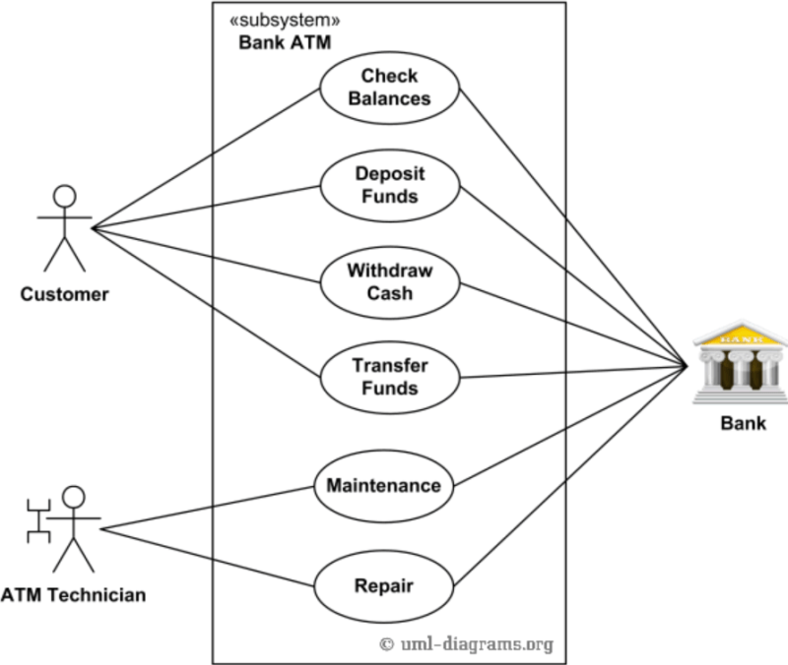
* Big Bang Integrations:
  + Integration of applications/components developed individually in the last phases of project
  + This generally ends up with issues & major reason for technical debt’s  
    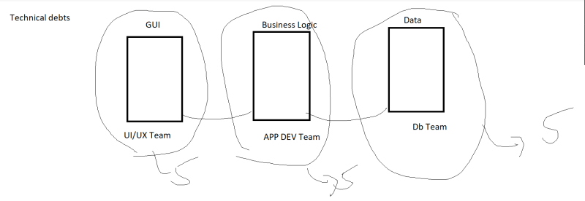
* Continuous Integration:
  + Here we integrate different components of the application from day 1 and ensure we run some integration tests
  + The basic idea is to fail fast and know the errors upfront.
* Agile Software Methodologies:
  + <https://agilemanifesto.org/> for the Agile Manifesto
  + DevOps enhances the idea of agile by approach which is shift left
* The idea of DevSecOps is to make security shift left.
* What is that we can do for this shift left of Security
  + Code to be scanned for security vulnerabilities
  + Scanning application deployed in various test environments for security vulnerabilities
  + Reporting the security issues and eventually breaking build when security issues are reported.
* DevSecOps Manifesto  
  